Project Report

Product Name | Implement Data Visualisation techniques using MS PowerBI
Qualification Name (NICF) | NICF Diploma in Business Analytics
Product Name | Data Queries and Visualization Basics
Module Name (NICF) | NICF Data Queries and Visualization Basics

Student name |  | Assessor name
Goh Rui Kun |  | Suryanto
Date issued | Completion date |  | Submitted on
8th Aug 2020 | 10th Aug 2020 |  | 10th Aug 2020
Project title | Student Registration Form Development

Learner declaration
I certify that the work submitted for this assignment is my own and research sources are fully acknowledged.

Student signature: RK Date: 10th Aug 2020

Content
- Project Overview 2
- Factors that influence Data Visualization 3
- Visualization Techniques 4
- Data Set Analysis 5
- Data Visualization 6

Project Overview: Describe the Project along with Project Outcomes and tools used (Explain the Project in your own words in 15 – 20 lines)
In this project we will analysis the data that are provided to determine the factors lead to high employee attrition rate than the normal attrition rate.
This dataset consist of 1470 employees with 35 of their details of information which will help us to find the cause of their attrition.
We will look through the data model and relationship between the main table and the look up tables and powerBI should create them automatically.
We will check that all the column in the dataset is on the correct data type. We will check for any missing value known as data cleansing.
After that, we will create new grouping like age group and new measure like calculating the attrition rate on the main table to the dataset.
Using the visualization tool in PowerBI, we conclude that there are 15 of the factors that leads to the attrition.
The factors that leads to the attrition are low job satisfaction, distance for home, department, Job role, overtime and business travel.
We have conclude that these are the main factors that contributed to 16.12% attrition rate.
Factors that influence Data Visualization: (List and Explain the factors such as static or interactive data, audience of data visualization, frequency of data visualization, level of details etc.)

- The first factor is Gender and Age group:
The Male attrition rate is 17.01% while female attrition rate is 14.80%. However, Gender is not considered as the factor that contribute to the attrition.
Next the age group, the highest attrition rate is below 20 years old which takes up 58.82%, however in terms of the highest number of attrition goes to age group between 20 to 39 where 20 to 29 have 81 attrition and 30 to 39 have 89 attrition. This have contributed to much of the total attrition.
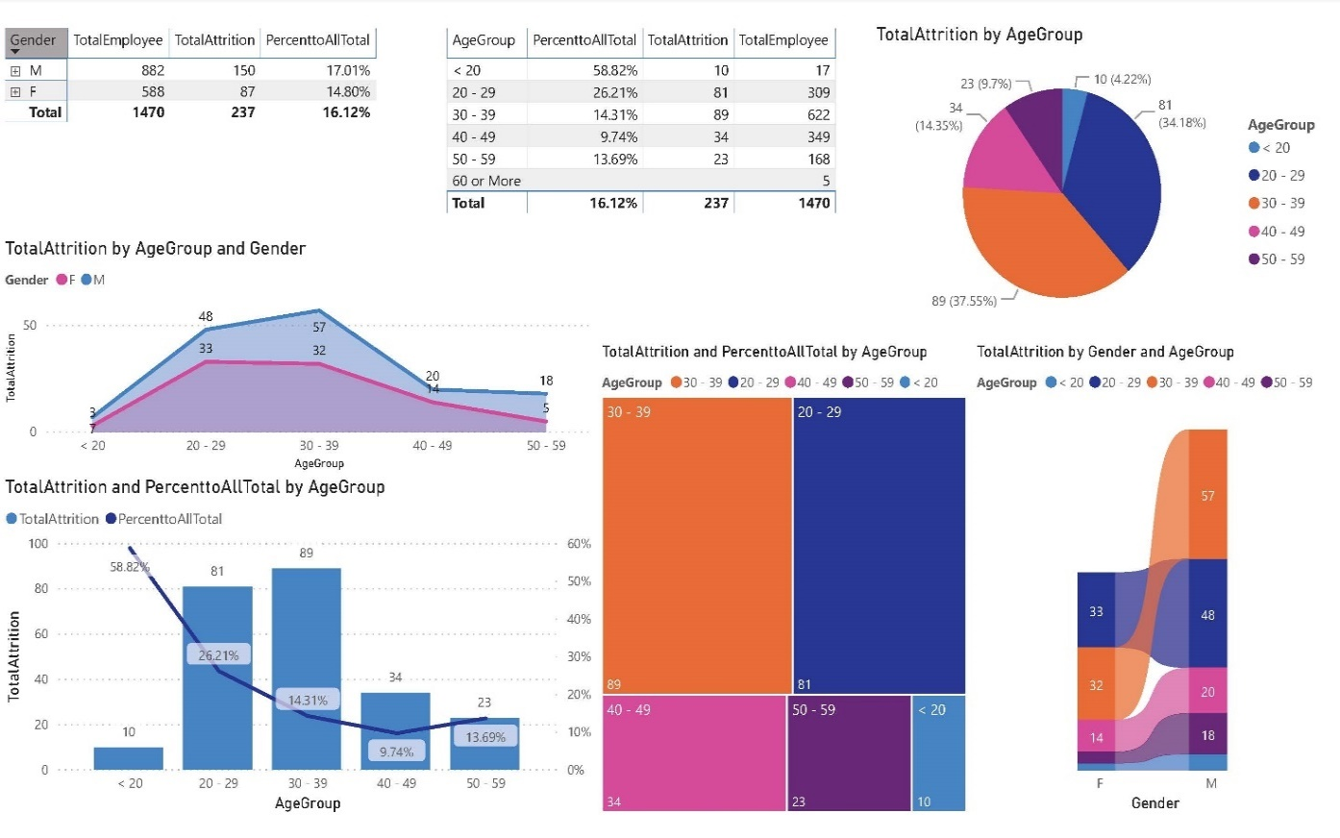
- The second factor is Department and Job Role:
From our findings we conclude that department might not be an obvious factor to contribute the attrition. For sales department we have 20.63%, Human Resources department we have 19.05% and Research and Development 13.84% of attrition rate. Research and Development department have the highest attrition number of 133. Next for the job role attrition rate, the highest is Sales Representation which have 39.76%, second highest goes to Laboratory Technician which have 23.94% and third highest goes to Human resources role which have 23.08%. However, in the terms of number of attritions, Sales Representation have the highest 57, followed by Laboratory Technician of 62 then Research scientist of 47. This conclude that Sales Representation and Laboratory Technician job role contributed to the high attrition rate.
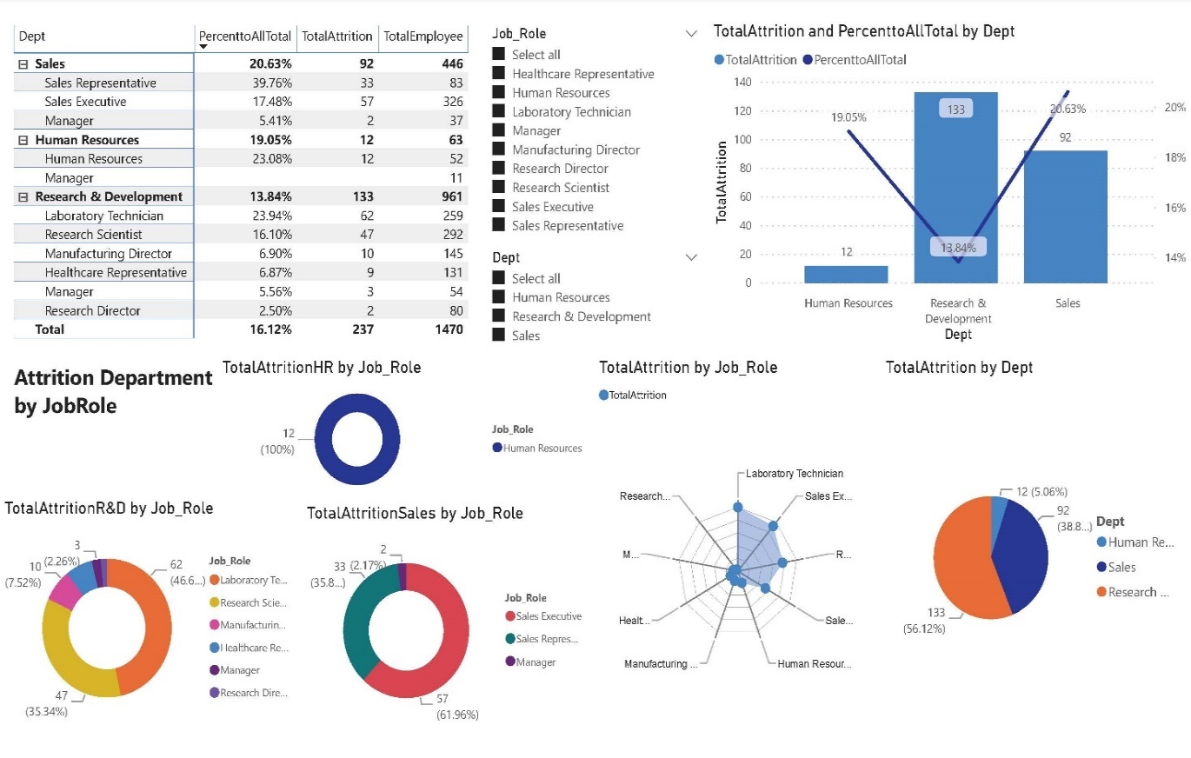

3. The third factor is Martial Status and Age Group:
The highest goes to single martial status which contributed 25.53% of the high attrition rate. Out of the single marital status, age group below 20 years old stands out to be the highest of 58.82%, followed by 20 to 29 years old of 38.60%.

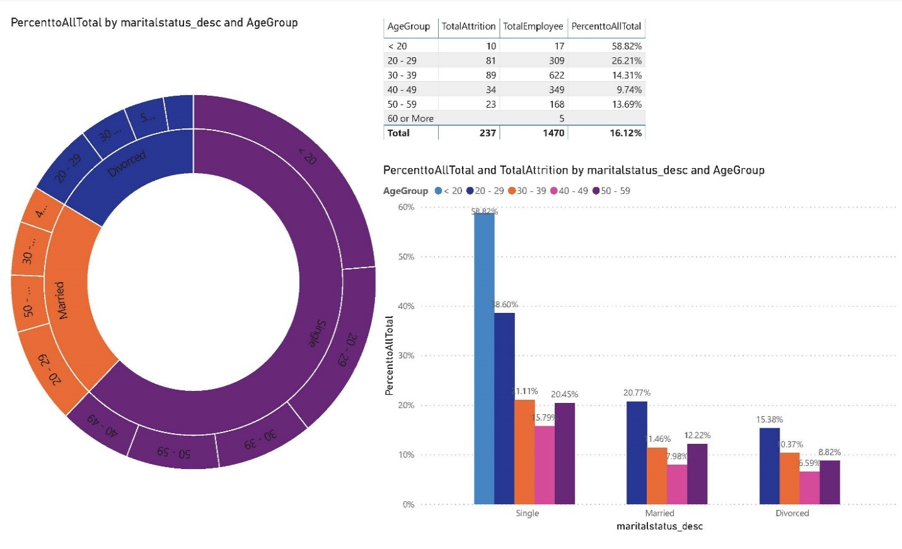
4. The fourth factor goes to Monthly income:
The highest attrition rate goes to the lowest income group which goes to Monthly Income below $2000. In terms of attrition number Monthly Income between $2000 to $3999 have the highest of 119.

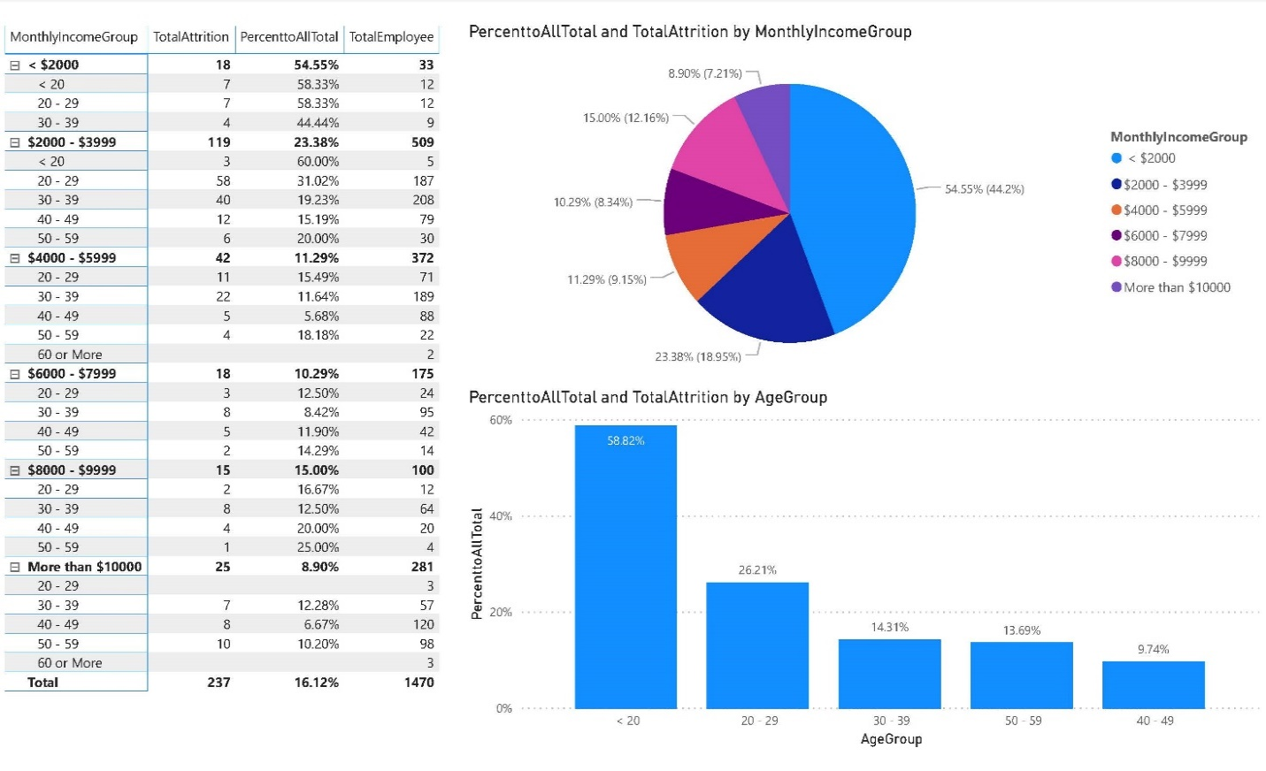

- The fifth factor goes to Age Group and Year in Company:
The highest goes to those who works less than 1 year in the company of 29.92%.

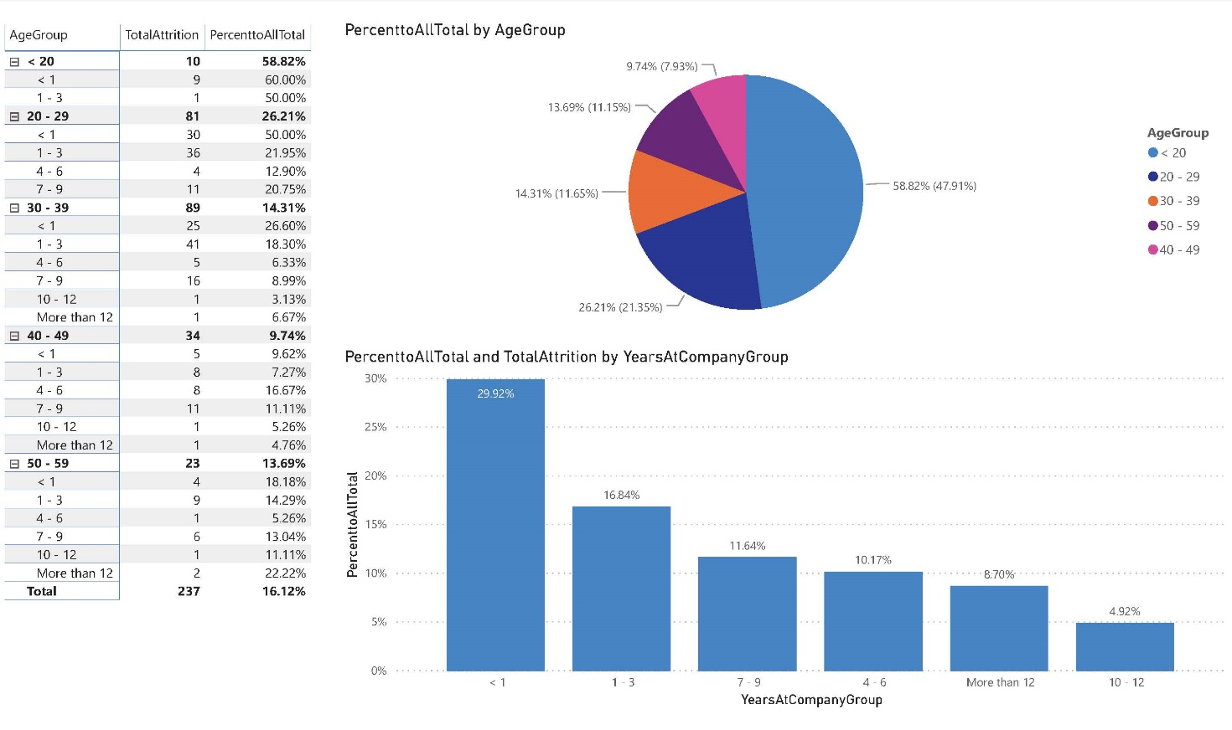

- The sixth factor goes to Overtime and Business Travel:
The highest goes to those who works overtime which figured 53.59% and 127 attrition. For the business travel it turn out to be the opposite where those who travel rarely turn out to contribute to the attrition rate of 65.82% or 156 in attrition figure.

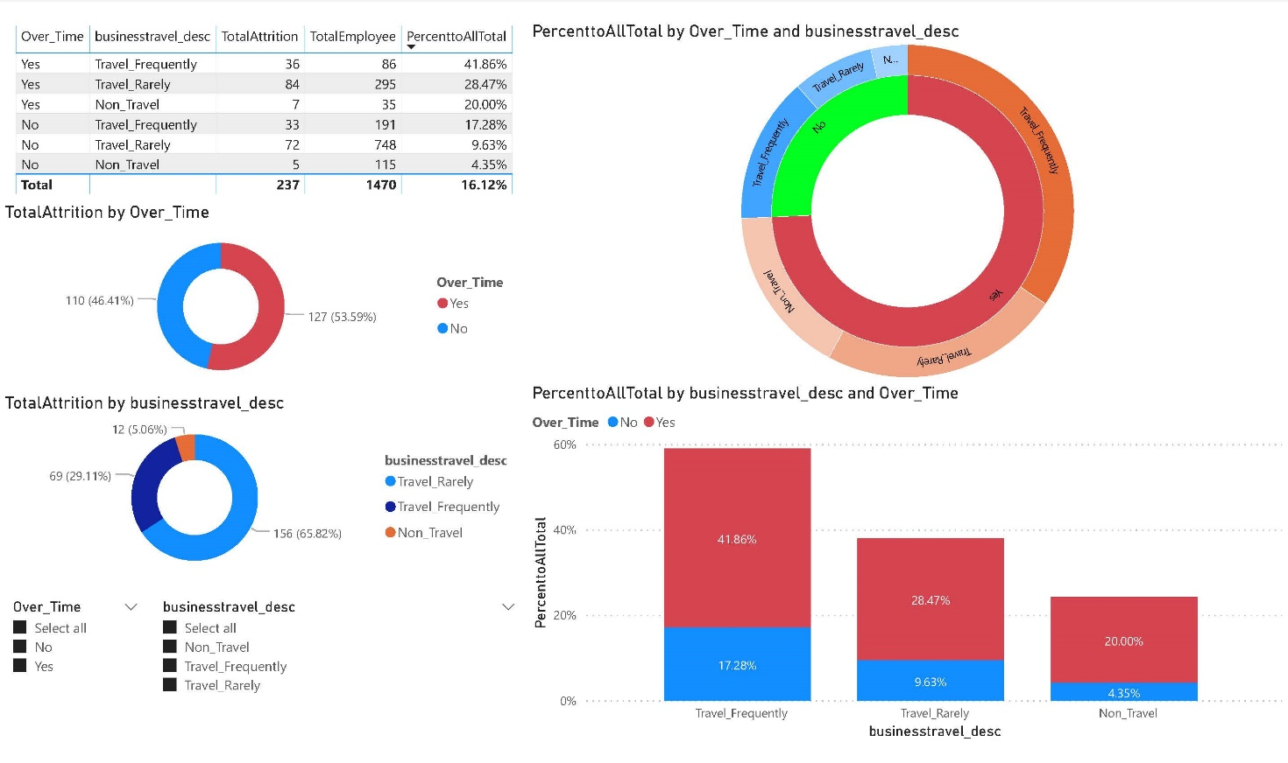

Project Visualization Techniques: (List and describe the visualization techniques considered along with justification why they were used or not used)
The visualization techniques used are table and matrix which are tabulate numeric data in rows and columns, row header, column header, subtotal and total segments, with sum and filter functions for correlated columns. Column chart which are used to compare data values across different categories and to display data as columns with different length representing the data values. Area chart to show how different data changes over x- axis. Radar chart to display multiple data values in the form of two-dimensional chart of 3 or more variables starting from the same middle point. Slicer to enable user to examine specific part of data visualization through filtering. Sunburst to display data sets in hierarchy format. Pie charts, Doughnut chart and Tree map to show different components of a whole such as fractions or percentage. Ribbon chart to display data as columns with different size portion representing the data values where the data values always displayed on the top of each category. Combination chart to display data set with measure of different scale where there are shared x-axis.
Data Set Analysis: (Analyse and list down your observations on total volume of data, growth rate, diversity of data and relationships between various columns of data): (you can put screenshot of Data Model from PowerBI and explain the relationship between tbl_EmployeeAttrition and other lookup tables – delete this italic notes from your report)
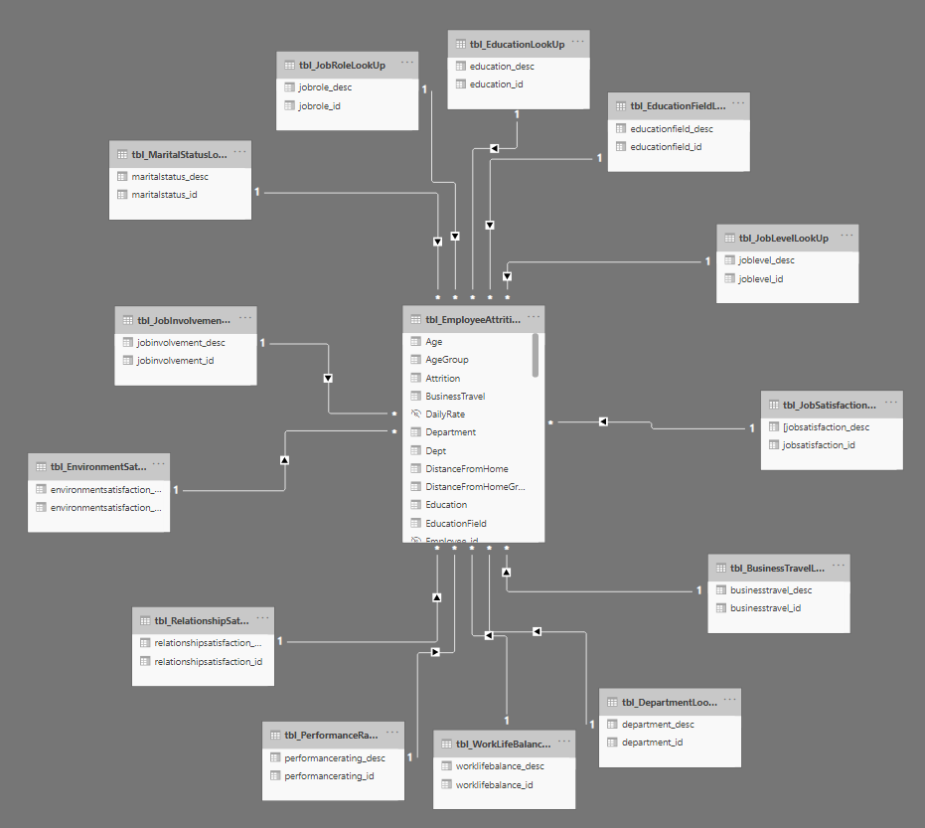
The relationship between various columns are shown above. The dataset provides information of 1470 records with 35 of their details.

Data Visualization: (Explain the process in which data visualization has been accomplished using the spreadsheet which you have created with data visualization)
Data preparation is required to convert raw data into more meaningful and readable form which include to verify all variables are in the correct data type and change to the correct data type if necessary. Next will be data cleansing which include remove any duplication records and resolve errors in the data. Next is to create new column for grouping some of the column variable such at Age Group, Monthly Income, Percent Salary Hike, Distance, Years Last Promotion and Years in Company. Next is to proceed to create new measure such as total attrition to calculate the total number of employee that left, total employee to calculate the total number of employee and percent to total for calculate the attrition rate to the total. After that will proceed for data visualization and findings.

